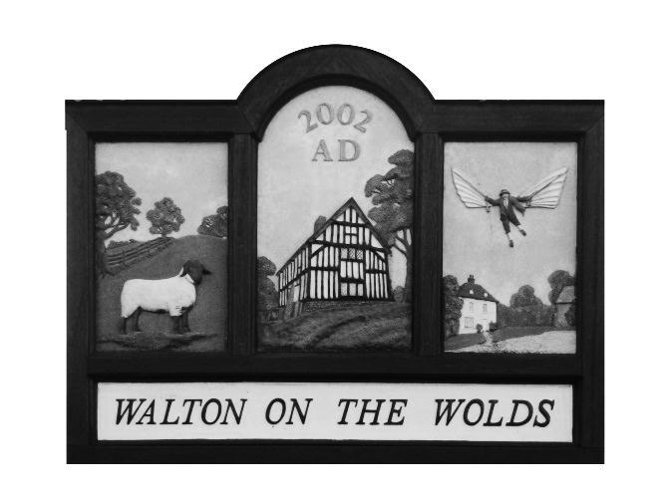
Walton on the Wolds Parish Council

12a New Lane
Walton on the Wolds
Loughborough
Leicestershire
LE12 8HY

Parish Council Extraordinary Meeting and Minutes

Tuesday June 7th 2023 at 6:30pm

at

The Anchor pub in Walton on the Wolds

Attended
Cllr G Archer
Cllr Lewin
Cllr Chair C Greenall
Clerk

An Extraordinary meeting was held to sign the AGAR forms to ensure submission by end of June.
The forms were signed by Chair Chris Greenall, in the presence of the two Cllrs.

