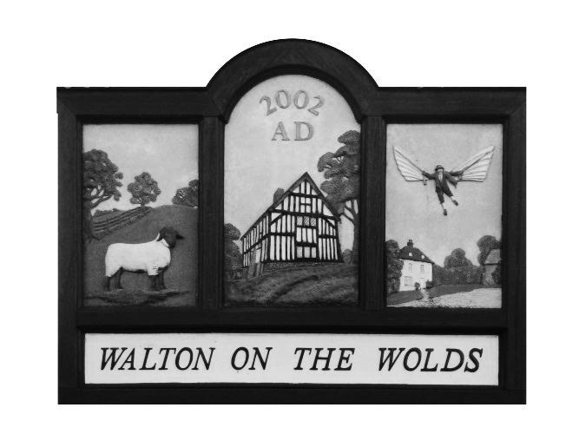
Walton on the Wolds Parish Council

12a New Lane
Walton on the Wolds
Loughborough
Leicestershire
LE12 8HY

Parish Council Meeting

Tuesday 9th May 2023 at 6:30pm

at

The Village Hall Walton on the Wolds

------------------------------------------------------------------------------------

PARISH COUNCIL AGENDA

The first 15 minutes are reserved for members of the public who may wish to make statement to the Council

- Apologies
- Approval of Minutes of the last meeting held on 7th March 2023

- To receive the Policing Report
  - Beat reports for February - March

- To receive the Borough Councillors Report and County Councillors Report
- To receive the Village Hall report
- To consider Matters Arising from the minutes of the last meeting

  - MVAS update – Parish Clerk
  - New lap -top for Clerk
- Village Maintenance – to receive and consider Clerk’s report – Appendix 1
  - The sign on the Nottingham Road has been replaced.

  - Fly tipping of wooden kitchen Cabinet on the Nottingham Road reported ad removed.

- Planning Applications

4 Planning applications have been received. To be discussed in the meeting.

a.
APPLICATION NO: | P/23/0424/2
PROPOSAL: | Erection of agricultural storage shed.
LOCATION: | Land off Black Lane, Walton on the Wolds, Loughborough,

- The expected planning application from British Gypsum has been made. The number application is Reference Number 2022/VOCM/0161/LCC

APPLICATION NO: | P/23/0458/2
PROPOSAL: | Retention of dwelling, detached garage and associated landscaping works (part retrospective) (Revised scheme to withdrawn application P/22/0509/2)
LOCATION: | 16 Six Hills Road, Walton On The Wolds, Leicestershire, LE12 8JF

- APPLICATION NO: | P/23/0279/2
PROPOSAL: | Erection of a free range poultry building and 4 silos
LOCATION: | Land off Black Lane, Walton On The Wolds, Leicestershire

- Correspondence
Nominations Pack for all Parish Councillors are uncontested. New Councillors, Mr Glenn Archer and Mrs Julie Lewin to join in the July meeting. They will be observers for this meeting.

Miss Christine Greenall has volunteered to be the new Chair of the Council and Ms Teres Dixon has volunteered to be the Vice Chair.

Training has been arranged for the new Councillors and also the Vice Chair by NRALC in Anstey and on line.

The new external auditors are now in place. AGAR process yet to be instructed. End of year finances to be approved. See below.

- Cheques and Finance
      - Cheques written: £50.00 to Louise Jackson for the plaque on the Bench to commemorate the Platinum Jubilee of our late Queen.

Current bank balance as of end February: £11,416.81

Assuming repayment of Chicane to LCC then the remaining balance stands at just under £6200. All of the expected invoices are now in and paid.

Agreement of the Parish Council accounts must be provided at this meeting.

Parish Clerk to set up process to collect VAT asap.

- Members’ Points of Information
Cllr Terry Lewis has begun the construction of the box for the book.
A family Disco is to be held on 6th May in the Village Hall from 7pm.

- Date of Next Meeting
  - July and full year of meetings to be proposed.

C HALL
Clerk

