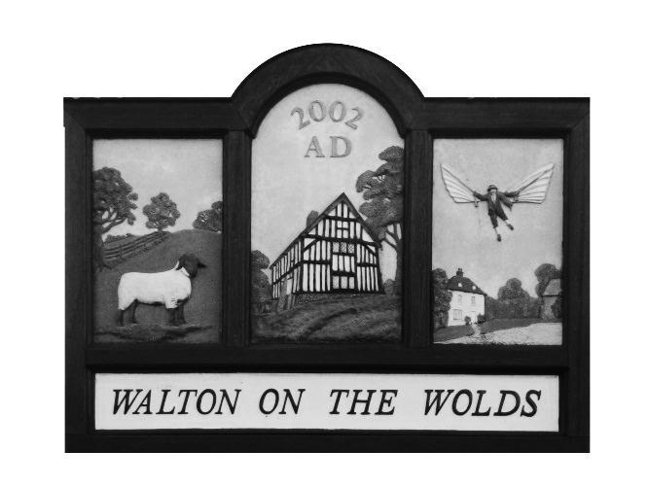
Walton on the Wolds Parish Council

12a New Lane
Walton on the Wolds
Loughborough
Leicestershire
LE12 8HY

Parish Annual Meeting

Tuesday 9th May 2023 at 6:30pm

at

The Village Hall Walton on the Wolds

------------------------------------------------------------------------------------

THE PARISH ANNUAL AGENDA

- Apologies
- Approval of Minutes of the last meeting held in March 2022
  - No minutes available as no points of governance raised nor resignations or new appointments made.
- To receive and consider proposed points of governance.
- Resignations or Councillor Appointments
  - Resignations received from B Parker, M Watson, and D Gilmore. They will attend the May 9th Parish Council meeting.
  - New appointments made for Mrs Julie Lewin and Mr Glenn Archer. They will take their place in the July meeting but observe at the May 9th Parish Council meeting.
  - The Chair is now Miss C Greenall and the Vice Chair is to be Ms Teresa Dixon.

Walton on the Wolds Parish Council

12a New Lane
Walton on the Wolds
Loughborough
Leicestershire
LE12 8HY

Parish Council Annual Meeting

Tuesday 10th March 2022 at 6:05 pm

at

The Village Hall Walton on the Wolds

------------------------------------------------------------------------------------

PARISH COUNCIL ANNUAL MEETING AGENDA

Apologies

Minutes of the Annual Parish Council Meeting March 2021

No minutes available as no points of governance raised nor resignations or new appointments made.

To receive and consider proposed points of governance

Resignations or Applications for Councillor appointments

No Resignations or new Appointments requested

Cheryl Hall

Clerk

