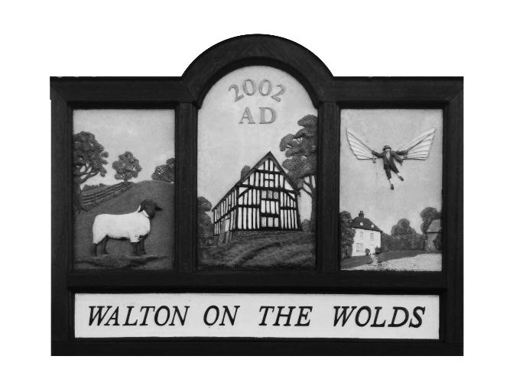

Walton on the Wolds Parish Council

12a New Lane

Walton on the Wolds

Loughborough

Leicestershire

LE12 8HY

Annual Parish Meeting

Tuesday 18th May 2021 at 6:00 pm

To receive feedback and or suggestions from the Parish on how effectively the Parish Council has served the Parish

Annual Parish Council Meeting

Tuesday 18th May 2021 at 6:15 pm

To elect or confirm the Chairman

Parish Council Meeting

Tuesday 18th May 2021 at 6:20 pm

All Meeting Held In Person

at

The Village Hall Walton on the Wolds

----------------------------------------------------------------------------------------

PARISH COUNCIL AGENDA

The first 15 minutes are reserved for members of the public who may wish to make statement to the Council

1. **Apologies**
2. **Approval of Minutes of the last meeting held on 9th March 2021**
3. **To receive the Policing Report**
4. **To receive the Borough Councillor’s Report and County Councillor’s Report, if present**
5. **To receive the Village Hall report**
6. **To consider Matters Arising from the minutes of the last meeting**
   1. **HGV’s using Village Road**
   2. **Speeding traffic and volume of traffic**
   3. **To consider the incident involving a parishioner and SUV mounting the pavement. Saturday 8th May 10 am**
7. **To consider the correspondence received** 
   1. **David Stead 2 letters. Available on request.**
8. **Planning Application – to agree such comments as may be necessary to the following applications**
   1. **Mast on Black Lane – pre application approach**
   2. **Vigilance on Six Hills private land**
   3. **Charnwood SHELAA Site Assessment PSH78. – related to correspondence by potential house purchaser**
9. **Planning application Policy** 
   1. **The Council will discuss and create a guidance submission of objections to Charnwood Council**
10. **Village Maintenance – to receive and consider Clerk’s report**
    1. **Speeding and traffic calming**
    2. **To consider the incident that occurred on Monday**
    3. **National Grid signage, New Lane. Sign up-ended – update from Clerk**
    4. **Litter picking – Picking sticks collected 14th May 2021**
11. **Cheques and Finance** 
    1. **to confirm payments made during this quarter.** 
       1. **Kriss Morrison Cooper overpayment £340.00**
       2. **Newsletter HP – invoice late payment £11.61**
12. **LRALC and NALC membership £159.65**
13. **Defib pads £46.80**
    1. **Receipts** 
       1. **Gamble & sons – £110.00**
       2. **Gamble & sons – £140.00**
       3. **E Kopel – Constables field rent - £350.00**
       4. **Charnwood Council - £2500.00**

**Current Community Bank Balance 12,770.95 (including £4800.00 costs for traffic calming build out, not yet claimed by LCC)**

* 1. **to receive and sign off the end of year accounts and the relevant AGAR documents**
  2. **to receive and sign off the adjusted Budget for 2021. Hard copy provided in meeting**
  3. **Charities Commission return for 2019 completed - £350 income only.**

1. **Members’ Points of Information**
2. **Date of Next Meeting**

C HALL

Clerk